**DISCUSSION PAPER ON THE TREND OF IAJ BUDGET**

Dear Colleagues,

In preparation of the meeting in Taipei, the Secretariat-General of the IAJ feels the need to share since now with you some important reflections about our budget, in accordance with the problems we already pointed out in the previous years, both in the Secretary-General and in the Treasurer’s reports to the Central Council. Problems, which have not been so far tackled by the PC and the CC, but which now cannot be put aside any more.

We started this financial year with reserves amounting to 216.583,53 euro.

At the date of this paper (13 July 2023), the **total amount of money available is 175.486,31 euro**.

Regarding **expenditure trends**, it must be noted that the annual budget is developed only on expected revenues, that is to say that the budget for the year 2022-2023 (from the Central Council in Tel Aviv to the one in Taipei) was 66.941 euro.

At the date of this paper, **all budget chapters are in deficit or close to deficit**:

1. *Meetings of the Presidency Committee*

8.000 € allocated, 13.470,19 € spent (deficit amounting to 5.470,19 €)

2. *Expenses of the President or his delegates, of the Honorary Presidents and of the rapporteurs*

11.122 € allocated, 9.400,84 € spent (remaining 1.721,16 €)

3. *Expenses of the General Secretariat*

35.819 € allocated, 49.938,44 € spent (deficit amounting to 14.119,44 €)

4. *Regional Groups*

|  |  |
| --- | --- |
| AFR | 3.000 € allocated, 5.244,03 € spent (deficit amounting to 2.244,03 € and reserves from previous years consequently amounting now to 16.211 €) |
| ANAO | 3.000 € allocated, 13.702,43 € spent (deficit amounting to 10.702,43 € and reserves from previous years consequently amounting now to 19.934,62 €) |
| EAJ | 3.000 € allocated, 4.533,35 € spent (deficit amounting to 1.533,35 € and reserves from previous years consequently amounting now to 13.024,06 €) |
| IBA | 3.000 € allocated,4.037,63 € spent (deficit amounting to 1.037,63 € and reserves from previous years consequently amounting now to 3.504,80 €) |

Regarding the expenses and their impact on the growing/consumption of the IAJ reserves, the following elements must be taken into consideration:

1. **no constitutional provision requires the establishment of reserves**. On the contrary, article 10 clearly states that “…the **annual contribution** [must be paid] to **meet the running costs of the Association**”;
2. in the handling of the IAJ's funds, the effort by the Secretary-General has always been to elaborate the annual provisional budget taking into consideration the expected income for the following 12 months, coming from the members' yearly contributions. If part of the income remained unspent at the end of the financial year, it was added to the IAJ bank "reserves";
3. the reserves accumulated by the IAJ until 2000 (74.339 €) were mainly due to the following factors:

* the lack of professional staff;
* the smaller dimension of the IAJ (57 members at the end of 2000; we are now 94) and the few institutional commitments, and thus the rarity of travels, of the members of the Presidency Committee and the General Secretariat;
* the fact that national associations were willing to cover with their own funds the travel expenses of the PC members holding their nationalities;

1. after 2000, the reserves have increased considerably, reaching their maximum amount at the end of 2016 (298.041,69 €). Since then, the trend of reserves has been downward, fluctuating in closing from -1.500 € to -32.700 € from the beginning of the financial year. At the end of the current financial year, the reserves will be about 122.000 € lower than in 2016 (***picture 1***);
2. the **Italian Association** (ANM) is providing, **since 2001**, an extraordinary contribution for the salary of the personnel of 12.395 € per year, that is to say that, up to 2022 the Italian Association donated in all to the IAJ so far, a total amount of **260.295 €**. It is worth noting that the contribution was given without ever pretending to select the staff, to interfere with the daily life of the IAJ, nor with its general policy or the order of its priorities;
3. the **expenses for the personnel** (salaries, pension contributions, salary of labour consultant) are at present **the largest expenses in the General Secretariat’s budget**. After the first assistant was hired in 2001, the special fund guaranteed by the ANM was sufficient for a long time, due to the fact that the contract entered into with the assistant at that time had few guarantees/social security costs (in particular, it did not provide for overtime pay and the pension contributions were very low). This is no longer possible **under current labour legislation**, so that now the assistants “cost” more and it has become **impossible to make savings with respect to the expenditures for the personnel**.
4. the **consumption of** **their** **reserves by the Regional Groups implies the diminution of the total reserves** of the IAJ, of which they are part as well as their savings contribute to the total reserves of the IAJ;
5. since the last increase in the amount of the annual contributions, in 2001, **the rate of inflation has grown**, with particular speed after the breakout of the war in Ukraine (***picture 2***).

(***picture 1***) trend of general IAJ reserves

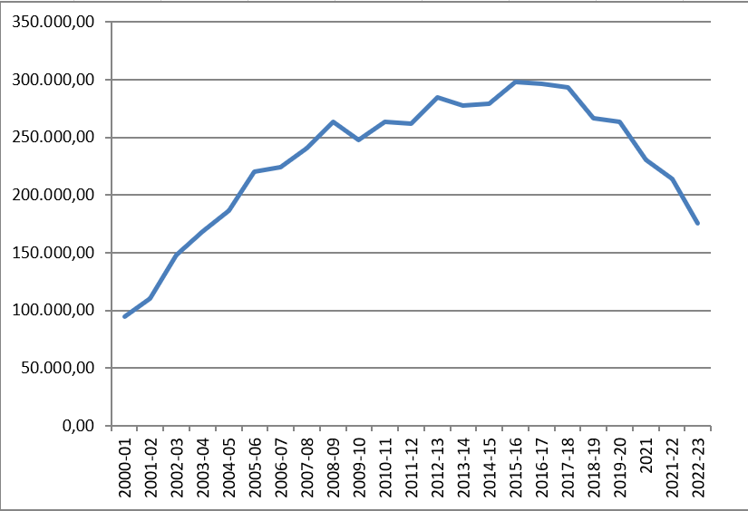

Given the recent downward trend in reserves, due to the impact of inflation, increased activities of the IAJ organs and personnel costs, and given that the IAJ is unlikely to increase its membership so much as to have significant increases in income, **we have to expect that, in the space of 10 to 15 years at most, reserves will run out and the annual incomes will not be sufficient to meet the running costs of the IAJ**, as foreseen by the Constitution.

A first remedy is to **consider** an increase in the annual contributions, at least **to compensate for the inflation**, what means an **increase of 38,50% (we repeat: just for compensating the inflation, with no substantial increase of the “value” of the annual fees)**

Please find hereinafter the present and the increased values of the annual contribution. The new value is determined by the Italian National Institute for Statistics.

|  |  |  |  |  |  |  |  |  |  |  |
| --- | --- | --- | --- | --- | --- | --- | --- | --- | --- | --- |
| Groups of cotisation |  | N° associations  per group |  | Annual fee |  | present total |  | appreciation ISTAT 3.2023 |  | total ISTAT |
| 1 |  | **17** |  | **1.767,00** |  | **30.039,00** |  | **2.643,43** |  | **44.938,31** |
| 2 |  | **4** |  | **1.178,00** |  | **4.712,00** |  | **1.762,29** |  | **7.049,16** |
| 3 |  | **18** |  | **706,00** |  | **12.708,00** |  | **1.056,18** |  | **19.011,24** |
| 4 |  | **55** |  | **352,00** |  | **19.360,00** |  | **526,59** |  | **28.962,45** |
|  |  |  |  |  |  |  |  |  |  |  |
| Expected incomes per year | | | | |  | **66.819,00** |  |  |  | **99.961,16** |

Dear Colleagues, it is precise duty of the Secretariat-General to point out that the situation needs prompt action by the Central Council (upon proposal, of course, of the Presidency Committee), through a consistent increase of our annual fees, so to at least allow us to recover the money we are losing and have lost due to rampant inflation. The defence of judicial independence worldwide is becoming not only a complex and a difficult question, but also a more and more expensive one. More and more often we are requested to participate in events and initiatives that we cannot ignore, otherwise we risk to be put apart and become irrelevant. If we want to keep on our decisive role, the credibility and the place we earned through decades of hard work in the world wide scenario, we must dispose of the means and resources that today’s world and international relations require. We are confident that you will understand our message and, together with the Presidency Committee, you’ll help us all to solve in a satisfactory way this problem.

The IAJ Secretariat-General